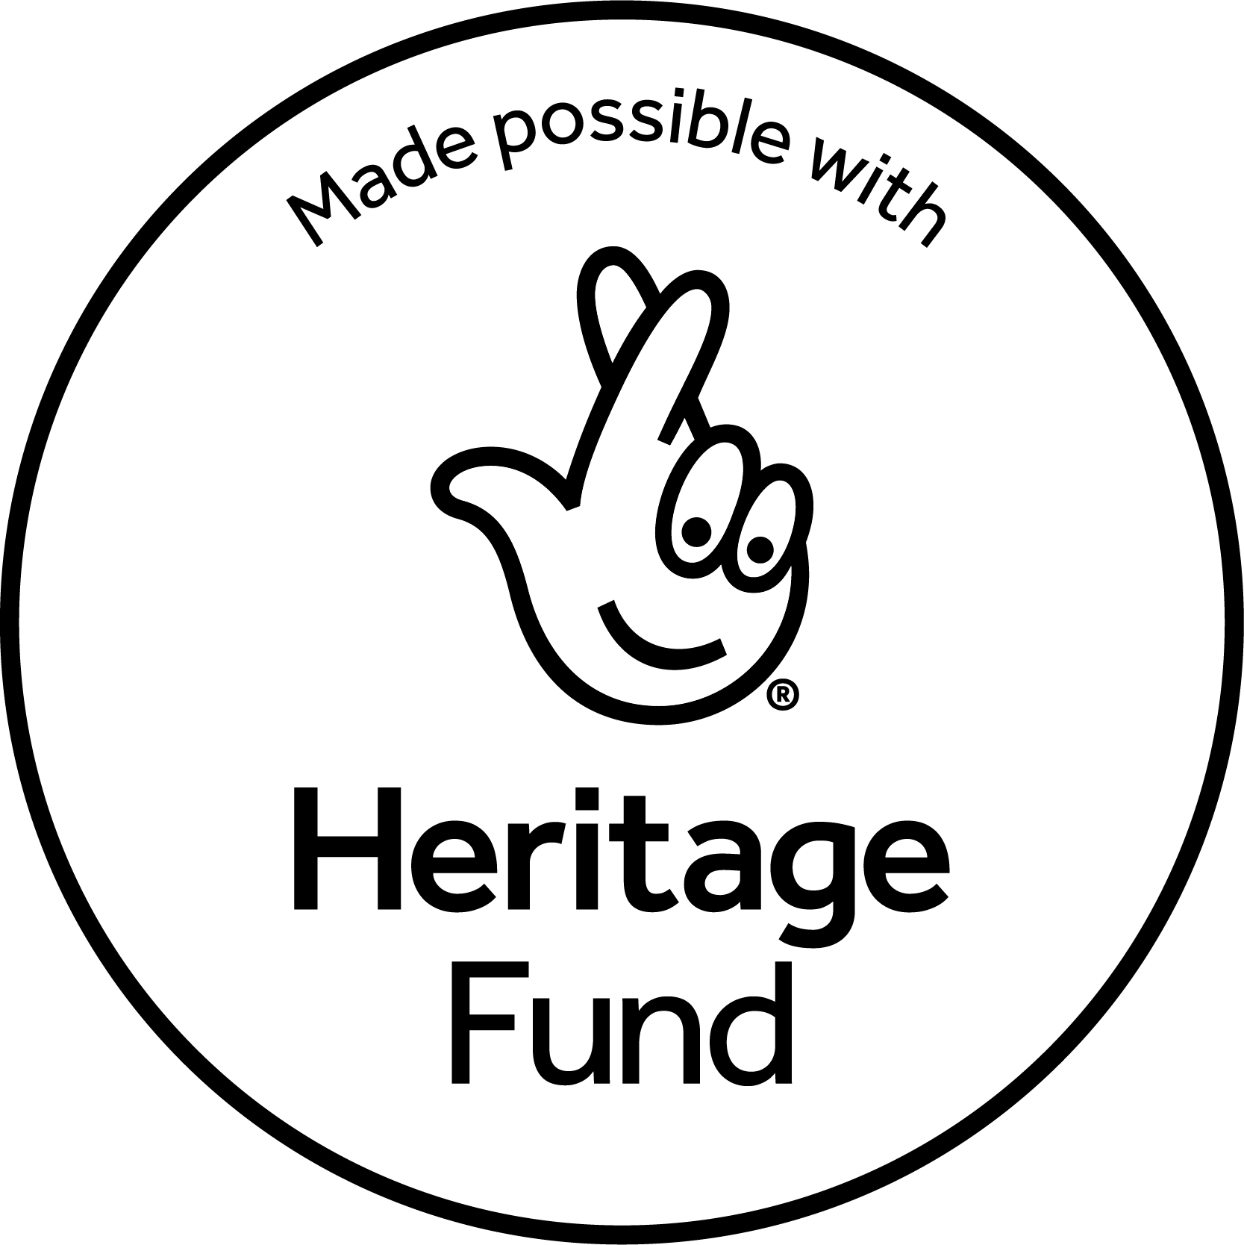
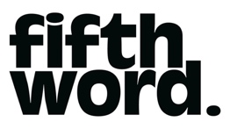
Executive Producer
Recruitment pack

ABOUT FIFTH WORD
Fifth Word are an award-winning theatre company based in the East Midlands, founded in 2007. We are dedicated to discovering, developing and producing the most exciting playwrights of today, and to working in-depth with under-served communities, empowering people to tell the stories that matter to them through different artistic means.

We produce and tour new plays that are powerful, bold and accessible: amplifying the stories of those who often go unheard and that connect particularly with younger audiences (14-25) and under-represented communities across the UK. We aim to shift perspectives and foster a love of theatre by harnessing its power for storytelling and human connection.

Our flagship engagement projects are created in collaboration with communities that often feel excluded from the arts. We focus on breaking down barriers, developing new talent, and celebrating fresh voices. Everything Fifth Word does is driven by a commitment to fostering creative ambition, championing emerging talent, and amplifying underrepresented voices.

Previous world premiere productions include Liberation Squares by Sonali Bhattacharyya (directed by Milli Bhatia; co-produced with Nottingham Playhouse, in association with Brixton House; national tour Spring 2024), We Need New Names, adapted by Mufaro Makubika from the Booker Prize-shortlisted novel by NoViolet Bulawayo (directed by Monique Touko; co-produced with New Perspectives, in association with Brixton House; national tour Spring 2023), LAVA by James Fritz (directed by Laura Ford & Angharad Jones; co-produced by Nottingham Playhouse for a full run in Nottingham in 2018 and then a national tour and Soho Theatre run in Spring 2022), All The Little Lights by Jane Upton (directed by Laura Ford; in association with Nottingham Playhouse; UK tour/Arcola Theatre 2017 – nominated for Best New Play by the Writers’ Guild Awards and OffWestEnd Awards; Joint Winner of the George Devine Award).

We’re industry leaders in writer development, launching initiatives like the Fifth Word Playwrights group and our previous Most Promising Playwright Award with Nottingham Playhouse. We’ve supported writers like George Devine Award winner Jane Upton and UK Poetry Slam Champion Toby Campion with their first productions.
Our key aims are to:
- Identify and nurture tomorrow’s most exciting playwrights
- Enable greater participation in the arts across the Midlands
- Invest in diversity
- Create productions for younger audiences that have something relevant and urgent to say about living in the world today
- Amplify underrepresented voices
- Produce world-class new writing across the UK

Our Values
EXCELLENCE
Creating high quality work that has the power to change perceptions and drive positive social change.

COLLABORATION
Working in collaboration with external partners to create the best possible opportunities and experiences for communities and audiences.

CREATIVITY
Empowering creativity in everyone and platforming under-represented voices in society.

INNOVATION
Embracing digital technologies and creating work outside of the traditional theatre space to reach more people.

INCLUSIVITY
Widening access to people who are under-represented in the arts and creating inclusive and positive experiences for all, regardless of background or experience level. Celebrating diversity, promoting equality, and challenging discrimination.

Our Current Programme
Our 2025/26 plans currently include:
- Showcasing, in June 2025, new work by writers on the Fifth Word Playwrights group (a 10-month programme of workshops and dedicated support for new and emerging East Midlands playwrights) in partnership with Nottingham Playhouse and Derby Theatre, supported by In Good Company and Writing East Midlands.
- Commissioning and producing the Pop Up Plays in Autumn 2025: up to 3 new plays that happen in alternative formats and settings outside of a traditional theatre auditorium, in collaboration with Curve and Derby Theatre and with support from Fuel.
- Developing our current commission, a new play by Sophie Ellerby, in collaboration with young people; working towards a world premiere production and tour of the play in 2026.
- Producing a flagship new community engagement programme, Our Story, in collaboration with Nottinghamshire Archives, Mansfield Museum, Loughborough University, Notts Trans hub and My Place Youth Centre. Our Story will amplify the voices of trans+ individuals in Nottinghamshire, through collecting new oral histories and then reimagining them into dramatised audio stories that will be shared as a podcast series, touring sound installation and pop-up exhibition during 2026.
- Instigating new seed commissions and holding research & development processes with young people for other plays in development.

Job Description: Executive Producer
Position: Executive Producer
Reports to: Artistic Director/CEO
Location: Hybrid
Salary: £37,500-£40,000 pro-rata (depending on experience)
Period of Contract: 4 days/week, fixed term for 12 months (with the intention to extend, subject to funding)

Role Overview:
Fifth Word is seeking a dynamic and collaborative individual to work closely with the Artistic Director/CEO in shaping the company’s strategic direction and ensuring its long-term sustainability.

The Executive Producer will help steer the company’s operations and planning, with a strong focus on financial sustainability and future growth. You’ll be instrumental in supporting the development and delivery of our new touring productions and in overseeing the delivery of our flagship community engagement programme, Our Story, made possible with The National Lottery Heritage Fund.

Key Responsibilities:
Strategic Planning & Community Engagement
- In collaboration with the Artistic Director/CEO and Creative Associate, develop and implement a long-term strategic plan with a strong focus on community engagement and inclusive representation
- In collaboration with the Artistic Director/CEO develop the Business Plan and oversee its implementation in line with strategic objectives.
- Monitor and report on progress against strategic objectives.
- Collaborate with the Artistic Director/CEO to research and evaluate community-led curation models, with a focus on advisory boards or panels.
- Oversee strategies for the company’s growth in brand development and communications.
- Establish and maintain effective relationships with partner organisations, touring venue partners, theatre partners, co-producers and funding bodies.

Management
- Work with the Artistic Team to continue to embed inclusivity across the organisation, with particular attention to fostering a welcoming and supportive environment for upcoming engagement projects with trans+ communities. This includes ongoing research and training to uphold best practices in recruitment, workplace culture, and inclusive language.
- Lead on further development of our evaluation framework to best capture feedback from participants, collaborators, volunteers, and people taking part in community consultation sessions. Explore new methods for gathering audience reactions to final outputs, both online and in person.
- Ensure effective policies and plans are in place, regularly reviewed and implemented to promote equal opportunity, access and diversity. Ensure compliance with best practice and with legal requirements, including employment law, data protection and environmental sustainability.
- Ensure that the wellbeing of staff and freelancers is maintained at all times, and that sufficient processes are put in place to monitor and safeguard that wellbeing.
- Support the recruitment and contracting of all project staff and freelance contractors, and any safety, wellbeing and HR matters.

Sustainability and Finance
- Establish partnerships with grant-making bodies, businesses, and philanthropic organisations and individuals to support our long-term strategic objectives.
- Alongside the Artistic Director/CEO, develop and execute a new fundraising strategy for the short and medium term.
- Lead on core fundraising applications, researching, writing and submitting bids according to Fifth Word’s fundraising strategy.
- Ensure compliance with funding body regulations, including the National Lottery Heritage Fund.
- Work closely with the Artistic Director/CEO and relevant project staff to oversee and review project budgets.
- Prepare, monitor and control annual budgets in line with the Artistic Director/CEO.
- Work with our accountants and the Artistic Director/CEO to prepare quarterly management accounts.
- Alongside the Artistic Director/CEO, reconcile monthly accounts using online software to ensure accuracy and up-to-date financial records.

Project Delivery and National Touring
- Oversee the planning, delivery, and evaluation of our new flagship community project Our Story, ensuring that all activities are executed effectively, on time, and within budget. Responsibilities include:
- Oversee project planning and delivery, ensuring milestones, activities, and funding requirements are met.
- Line-manage project staff and oversee day-to-day operations, including workshops, training, and exhibitions.
- Assist in organising and contributing to steering group and safeguarding committee meetings alongside the Engagement Producer and project partners.
- Oversee the project evaluation.
- Prepare timely reports for funders and stakeholders.
- Increase the visibility of our digital platforms, enabling more people to engage with our work. Collaborate with the Digital Communications Associate to develop and deliver a digital marketing strategy that grows our social media following and broadens our online reach.
- In collaboration with the Artistic Team, lead on the producing of our touring productions, including our new initiative, Pop-up Plays (theatre outside of traditional spaces).
- Alongside the Artistic Director/CEO and the Creative Associate, identify and secure partners, collaborators and co-commissioners for our productions.
- Work with the Artistic Director/CEO to ensure that appropriate and viable schedules and tour arrangements are in place.
- Work with the Engagement producer to support the delivery of wrap-around engagement activity in line with Fifth Word’s strategic objectives.
- Work with external providers to oversee the development and delivery of Fifth Word’s Marketing and Audience Development strategy.
- Improve audience data-gathering processes and ensure their implementation.
- Line-manage Fifth Word’s Digital Communications Associate, whose duties include managing social media platforms, drafting newsletters, managing Fifth Word’s CRM systems and developing and delivering digital marketing strategies.
- Support our Creative Associate in developing and delivering our artist development programmes (e.g. Fifth Word Playwrights); actively contribute to identifying and securing partners and collaborators for these initiatives.
- Support the producing and delivery of R&D processes for commissioned writers, in collaboration with the Creative Associate and Artistic Director/CEO.

Governance and Board
- Work with the Artistic Director/CEO and Trustees to ensure the company maintains the highest standards of governance and strategic planning.
- Develop effective working relationships and positive engagement with all Trustees. Attend Board meetings and any other committee meetings or working parties as appropriate.
- Prepare papers for Board Meetings and take minutes of the meetings to ensure Board members are kept informed on finance, legal, strategic and operational issues.
- Ensure Fifth Word is compliant with all statutory requirements including insurance, the Charity Commission and Companies House.
- Assist the Trustees to discharge their legal responsibilities, both as charity trustees and company directors, ensuring that they receive accurate and timely information enabling them to make informed decisions.

General:
- Attending press nights, other events and fundraisers as required.
- Lead weekly team meetings as required.
- Research and organise team-wide training as required.
- Support light website updates as needed (e.g. adding news, events, copy).
- Advocate and lobby for Fifth Word, seeking opportunities to promote the organisation across partnerships, stakeholders, funders, and the wider theatre community.
- Any other duties of an executive nature as determined from time to time by the Board.

Person Specification

Essential Skills & Experience
- At least four years experience in performing arts management or equivalent in another sector (e.g. an organisation with a national reach, or a charity)
- Experience in, or exposure to, executive leadership of a cultural organisation or equivalent in another sector
- Excellent financial management skills and experience of budget management and finance systems
- An entrepreneurial, ambitious and collaborative strategic thinker with a view to how Fifth Word could develop over the next five years
- Strong leadership and interpersonal skills to deal effectively with internal and external relationships
- An interest and enthusiasm for Fifth Word and its objectives
- An understanding of the UK’s theatre and arts ecology
- Impeccable organisational and communication skills
- Excellent people management and motivational skills
- Proven success in fundraising and experience of developing strategic fundraising plans
- Ability to create effective partnerships

Desirable Skills & Experience
- Experience in the subsidised or charitable not-for-profit sector
- Experience of managing funding from Arts Council England and/or the National Lottery Heritage Fund
- Experience in delivering community engagement and/or heritage work
- Experience of working with a Board of voluntary trustees
- An understanding of the legal requirements of a charitable organisation
- Previous working relationships with venues and arts organisations across the UK
- Experience and/or knowledge of the theatre ecology/under-served communities in the East Midlands
- Experience of producing touring work and awareness of the current British touring environment
- Experience in promoting diversity and inclusion
Equality, Diversity and Inclusion
We are an equal opportunities employer, and we encourage applications from all suitably qualified persons, regardless of race, sex, gender identity, disability, sexual orientation, religion/belief or age. We actively welcome applications from those currently under-represented in the arts sector.

Terms of Employment

Salary | £37,500- £40,000 (depending on experience)
Contract | 4 days/week, fixed term for 12 months (with the intention to extend, subject to funding)
Pension | Auto-enrolment in the company pension scheme with 3% employer contribution
Hours | 28 hours/week (excluding breaks). Evening and weekend working may be required. If additional hours are worked no overtime will be paid, but time off in lieu (TOIL) can be taken by arrangement with the Artistic Director/CEO
Holiday | 28 days paid holiday per annum inclusive of bank holidays (pro-rata for part time working)
Probation | Six months
Location | This is a hybrid role- with most work being undertaken remotely. Applicants can be based anywhere in the UK. Ideally with commutable distance to the East Midlands. We are a small company and have always encouraged flexible ways of working and are open to different ways the postholder may like to work.  We are an arts company with a lively schedule of events and projects, producing at least one major production annually. This means that there is a managed expectation to travel, work some unsociable hours, and work flexibly in terms of role requirements and hours at certain points in the annual calendar. These periods are planned well in advance and will be managed in liaison with the post-holder.

How to apply
The deadline for applications is Friday 6th June 2025, 12 noon
Please send a covering letter (no more than two pages) outlining what you bring to the role, your reasons for applying, and how your skills and experience fulfil the personal specifications.

In addition, please submit a CV, details of two referees (they will not be contacted prior to interview) and a completed equal opportunity monitoring form, available here.
Please submit your application to info@fifthword.co.uk with the subject line ‘(Your Name) – Executive Producer Application’ by the deadline above.

Questions for us?
If you would like this information in an alternative format, have any questions about the role, or would like to apply in an alternative way, please contact info@fifthword.co.uk

Shortlisting and Interviews
All applicants will be notified by email to confirm whether they have been shortlisted. First round of Interviews for shortlisted candidates will be held the week commencing 16th June. We are keen to have the post holder start as soon as possible, though factoring in any necessary notice periods.

Thank you for your interest in the role – we look forward to hearing from you.
Website: www.fifthword.co.uk
Instagram: @fifthword_theatre
Facebook: @FifthWordTheatre
X: @FifthWord
YouTube: @fifthword
Registered charity. 1211532 Registered company in England and Wales 06581404/ ITC Member

